Entering Leave for an Employee Without a Substitute
Payroll > Maintenance> Leave Account Transaction> Staff Leave Maint
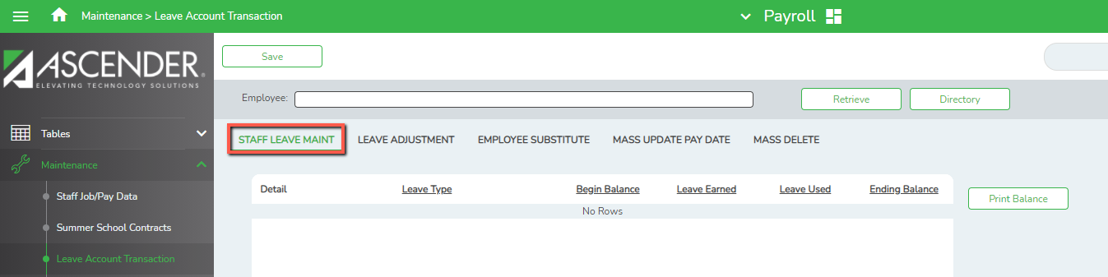
- Type the Employee’s name or number in the appropriate field and select retrieve. (You may also use the directory to search for an employee)
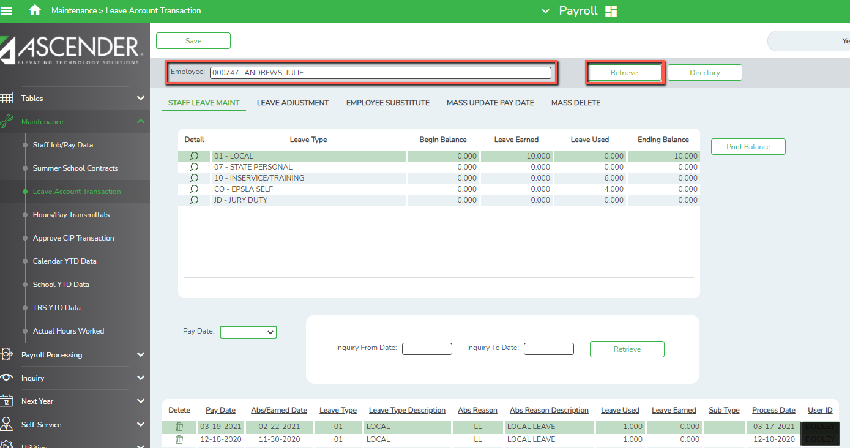
- Once you have selected retrieve, information for that employee will populate. You are now ready to add the leave by selecting the pay date that you are currently working on. Then you will click add to enter the leave information and Save.
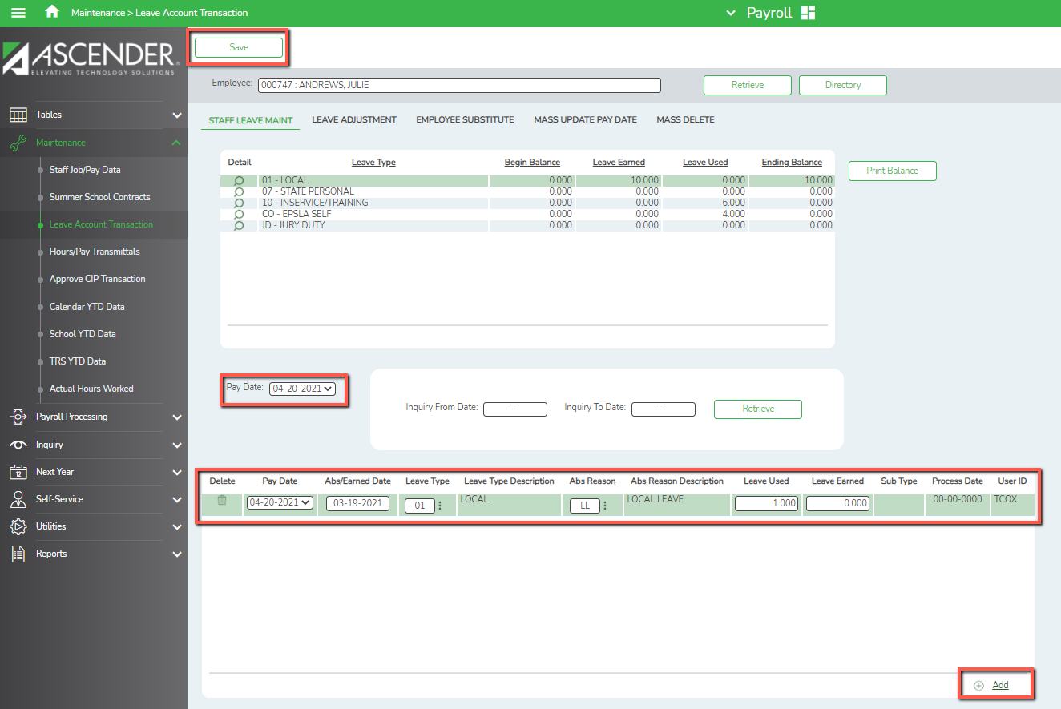

Entering Leave for an Employee With a Substitute
Human Resources> Maintenance> Leave Account Transaction> Employee Substitute
- On the Employee Substitute tab you will enter the Employee’s name or number in the appropriate fields, select the pay date you are working in, and then click retrieve. Next you will enter the Frequency, Sub Pay Date, and enter Sub Employee Number or Sub Name and select Retrieve.
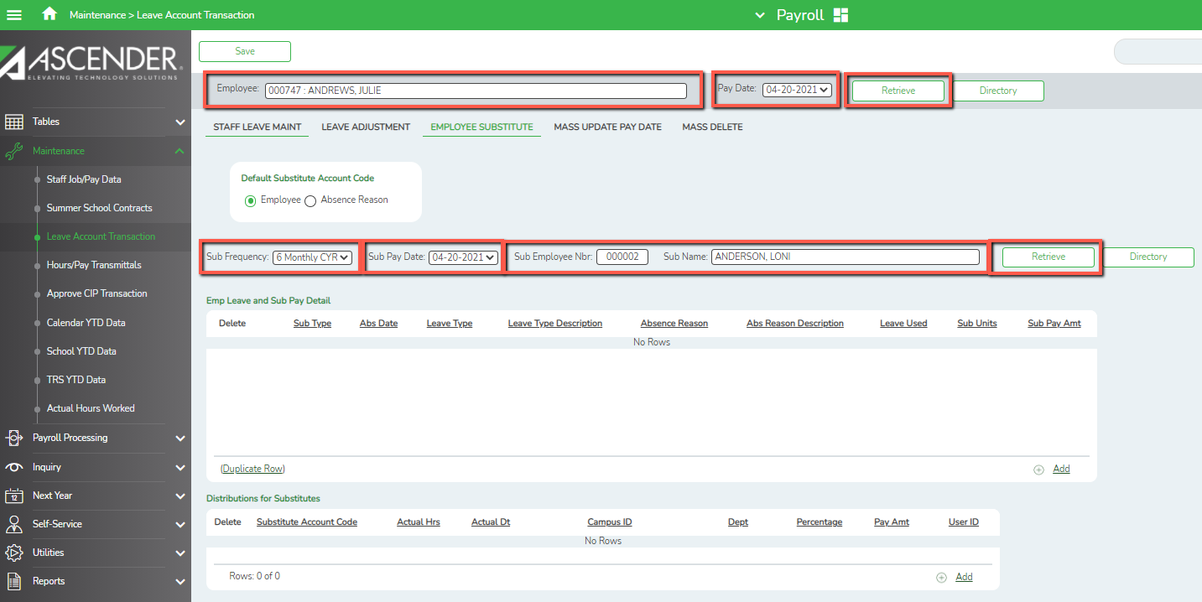

- Next, you will enter the leave information by selecting the Add button in the Emp Leave and Sub Pay Detail Section. Here you will choose the sub type, absence date, absence reason, and amount of leave used. The Sub Pay Amount will populate automatically based on the sub type chosen in the Staff Job/Pay Data Screen.
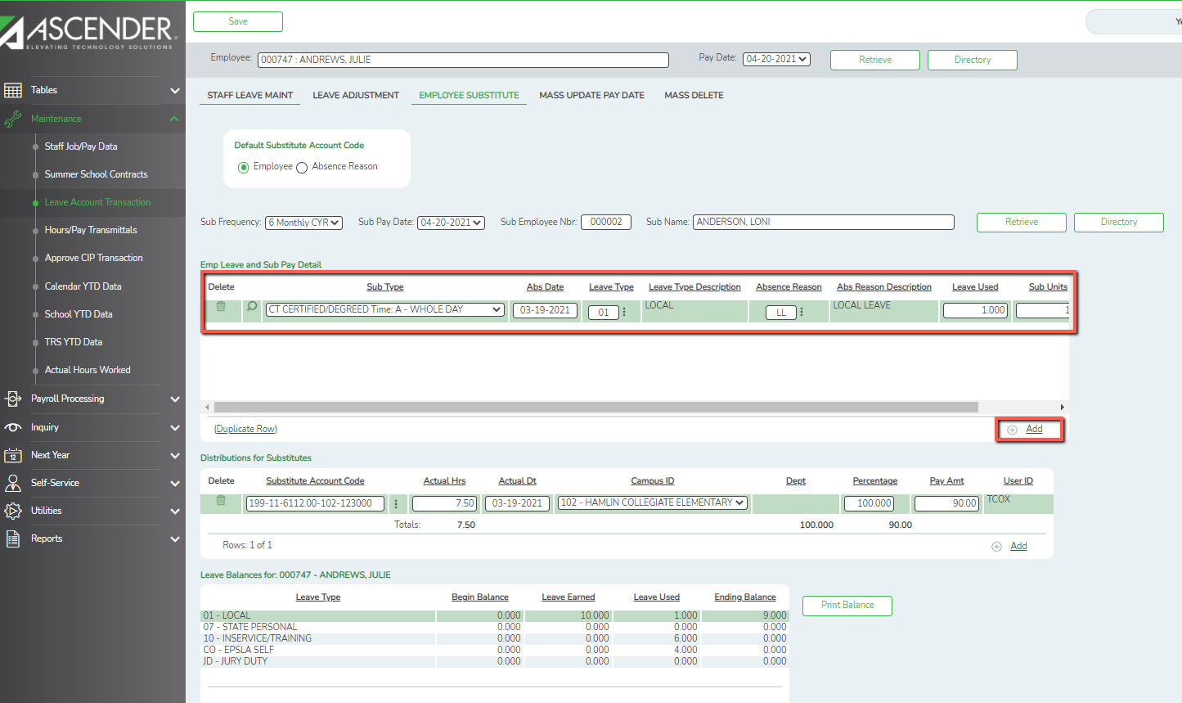

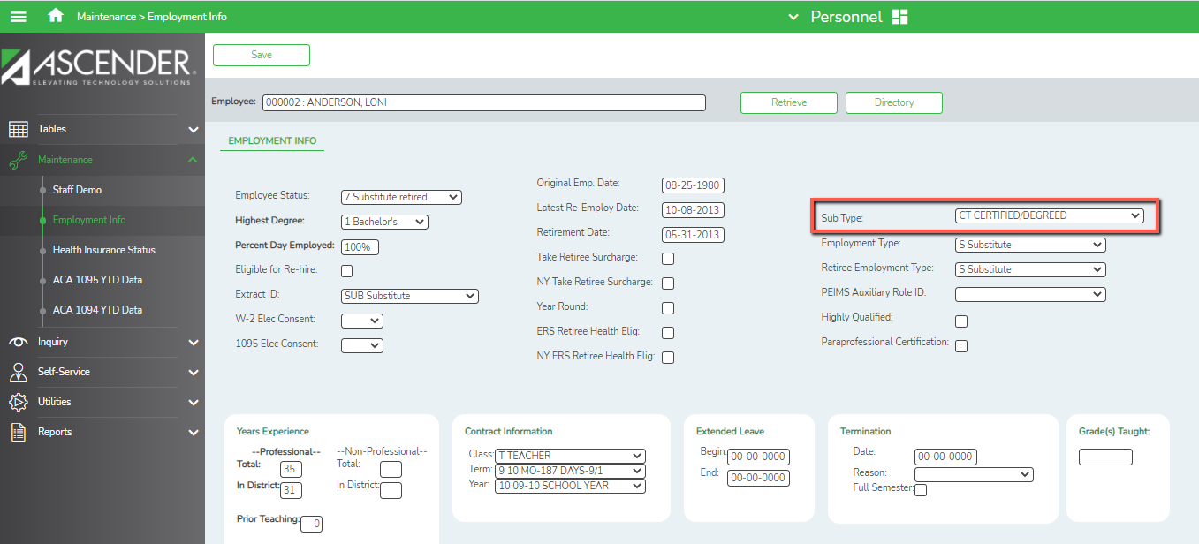
(Note: on the Personnel > Maintenance> Employment Info Screen there is a field that allows you to choose a sub type. This will save you time instead of having to look up each Substitute to find out if they have a degree or not.)

- Next, you will select add on the Distributions for Substitutes section. You will verify the Substitute account code and then enter actual hours, actual date. The Campus, Percentage, and Pay Amount will automatically populate. Verify this information, then click save.
